RAILWAY SECURITY SYSTEM

Abstract:

Our project “Railway Security System” automatically traces the track discontinuity several kilometers ahead and alarms nearby station and the Train about the track discontinuity.

In this project, we use series of sensors which senses the continuity of the track by sensing the vibration in the track.

When a train passes its vibration in track it travels with very great velocity than the train velocity so that it can be detected several kilometers ahead before the train. we use a series of sensors which detect the vibrations from the track. The output of the sensors are fed to the switching and rectifying circuit which processes the sensed signal ready to feed for the microcontroller. The processed signals are first fed to the opto couplers, output of which is fed to the microcontroller. The microcontroller decides from the received signal about the track discontinuity, and when a discontinuity is found in the track.

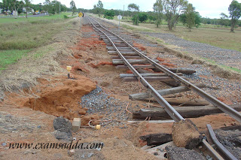

BLOCK DIAGRAM:

